7. Dictionaries Manipulation

Table of Contents

|  |  |  |
| --- | --- | --- |
| Sl. No | Topics | Page No |
| 7.1 | **Dictionaries Manipulation** | **2** |

## 7.1 Dictionaries Manipulation

**What is Dictionaries?**

Dictionary is an unordered collection of key-value pairs.

It is generally used when we have a huge amount of data.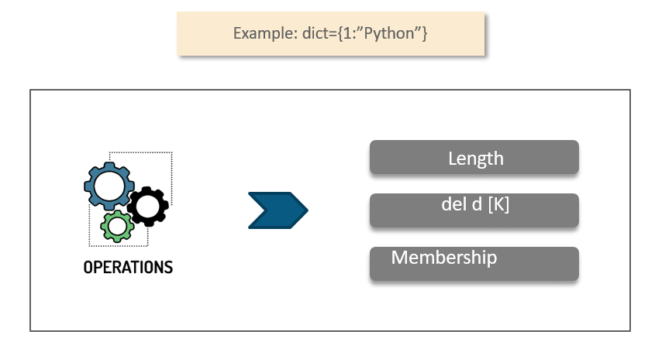

**When to use Dictionaries?**

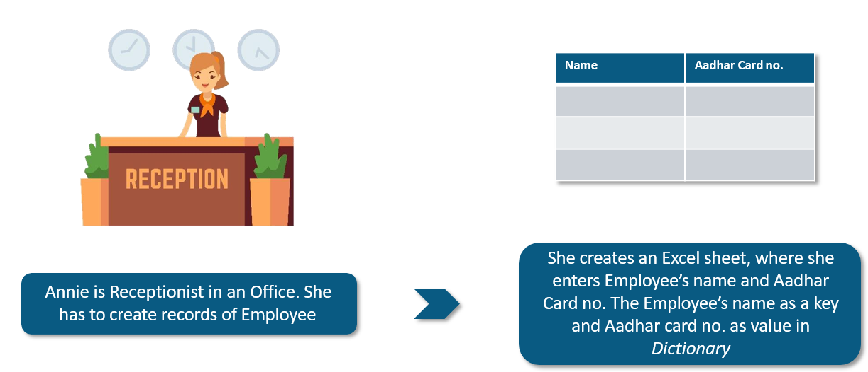

**Dictionaries Operations**

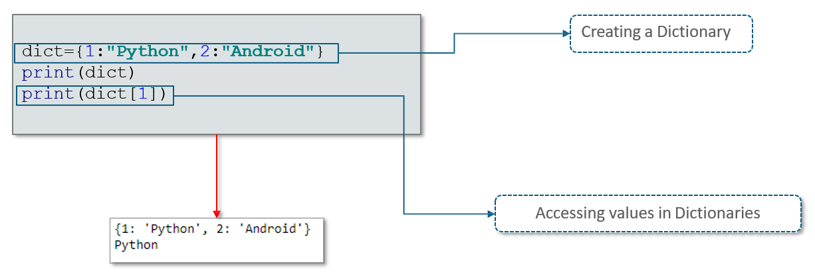

**Dictionaries - Updating and Deleting Elements**

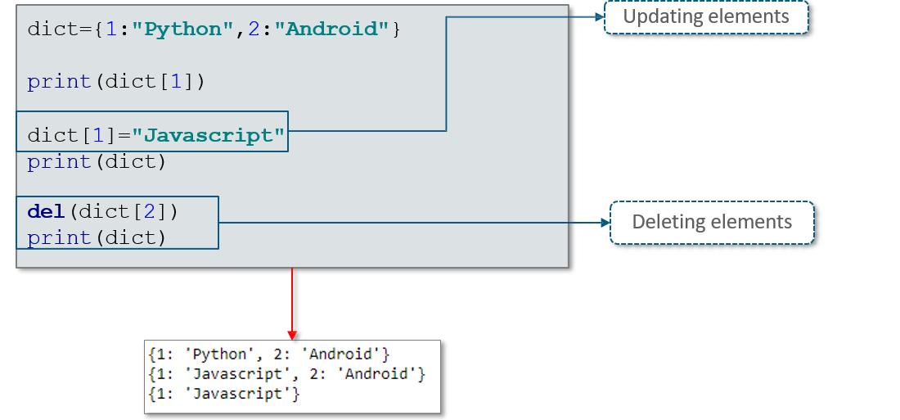

**Built-in Functions of Dictionaries**

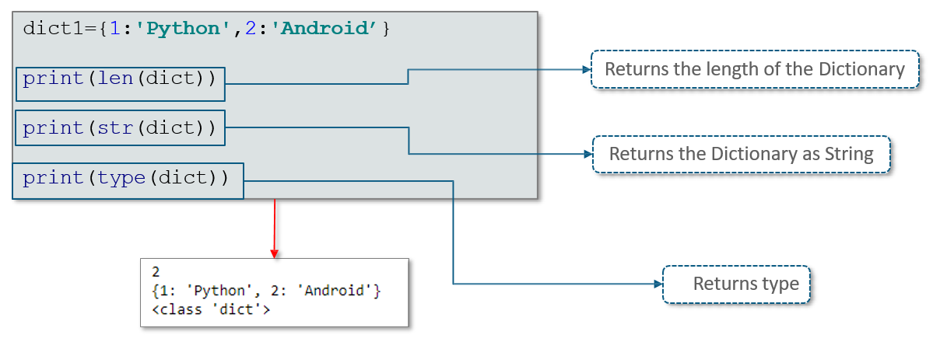

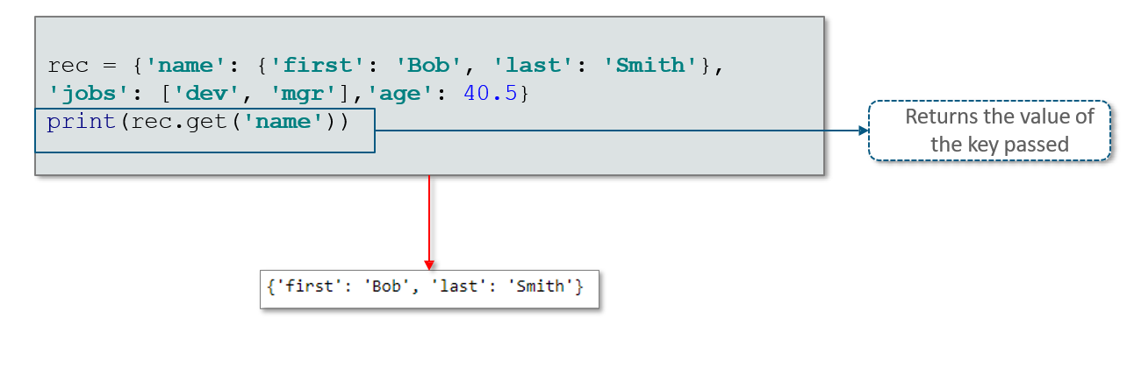

**Methods of Dictionaries**

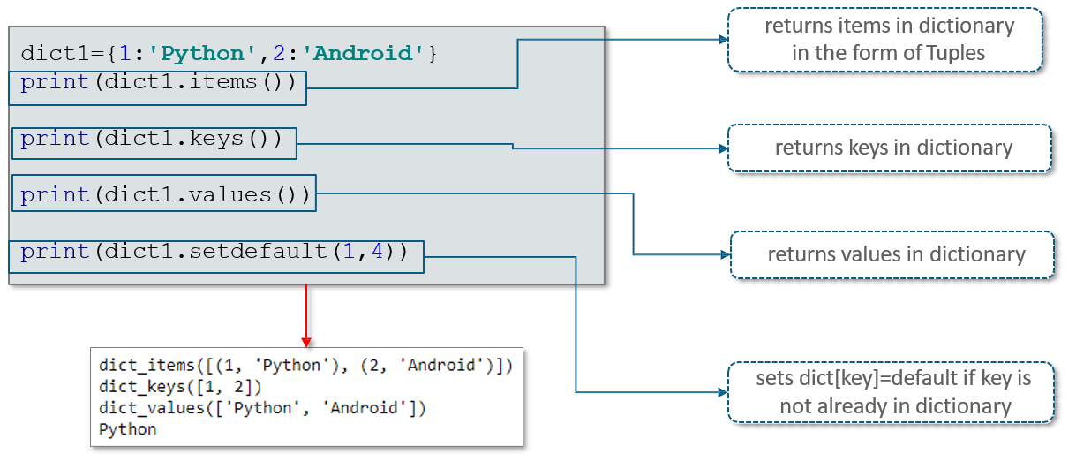

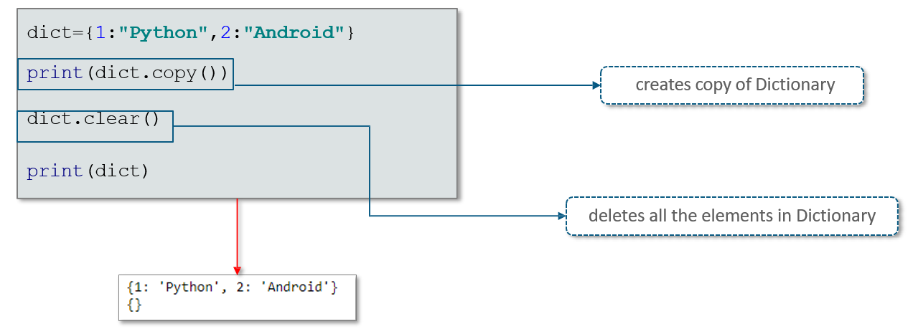

**Sorting Keys for Loops**

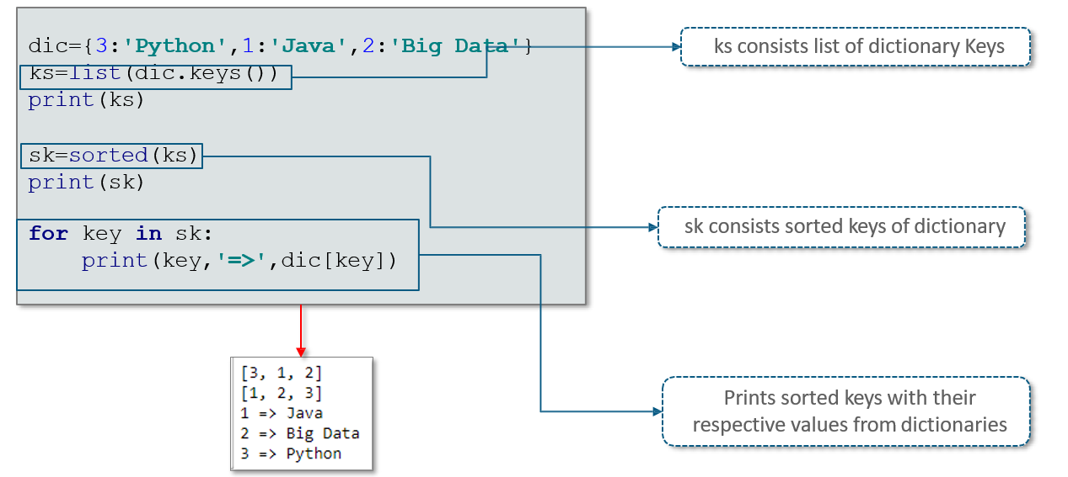

**Tuple and List in Dictionary**

